Reinstalling Network Components and DUN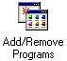:
Reinstalling Network components and DUN is one of the last steps in fixing a connection or surfing problem on your computer. Just as you would replace a broken blade in your lawnmower, you would replace "broken" software in your computer. Your lawnmower may seem to work just fine most of the time with one broken blade, or may not work at all. Your computer may seem to work just fine most of the time with a few corrupted software components, or it may not work at all. Replacing the software, as replacing the lawnmower blade, makes things work exactly as they should.
If you are having problems surfing or connecting, this may indicate a problem with the installed networking components on your computer. You may get any number of errors when attempting to connect to the Internet. Or, you may be able to get connected, but then not be able to browse to any websites.
You could uninstall and then reinstall one component at a time, rebooting and trying the connection again at each step. This could end up consuming hours, however. So, we'll present the quickest procedure for uninstalling and reinstalling your computer's networking components.
1) Uninstall TCP/IP
2) Uninstall Dial-up Adapter
3) Uninstall DUN
4) Reboot
5) Run the inetwiz
Note: Step 5, run the inetwiz, covers 4 steps in one. It will reinstall DUN, Dial-Up Adapter, and TCP as well as create a new connection.
The entire uninstall/reinstall procedure is the subject of the rest of this page.
Check for Windows CD or .cab files:
You must have either your Windows 98 CD or .cab files already on your computer to be able to reinstall network and DUN components. The Windows 98 CD is the best bet since the .cab files are more likely to be complete and uncorrupted. Do not confuse your Win98 CD with your PC manufacturer's Restore Disk.
If you do not have the Win98 CD, you can use the .cab files hopefully already stored on your computer. By default, Windows 98 does not have the .cab files installed, so you may not have them. Here's how you can find out.
To check for .cab files, click the Start button, then choose Find, then choose Files or folders, as pictured below.
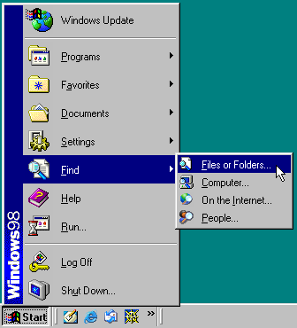
The "Find" window is pictured below. Make sure that the Look in box is pointing to the C: drive. If not, click the drop-down arrow at the right side of that box to choose the C: drive.
In the Named box, type w*.cab and hit the Find now button. You will get a response similar to the one pictured below. In the "Name" column there should be about 50 of these .cab files, numbered from "Win98_21.cab" up past "Win98_72.cab"
In this example, you can see that the "In Folder" column points to a bunch of cab files in "C:\Windows\Options\Cabs". Write down whatever folder yours are in, as you'll need this address soon.
Note: Most computers have these stored in "C:\Windows\Options\Cabs".
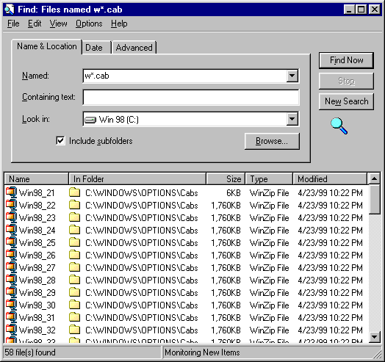

!! DO NOT CONTINUE IF you do not have these .cab files !! You will have to locate your Win98 CD to continue the reinstallation.

Uninstallation:
Uninstall Network Components:
Open the Control Panel by going to Start->Setting->Control Panel.
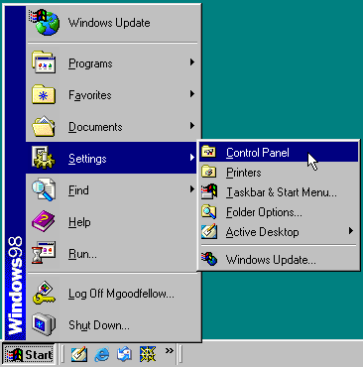
Double click on the Network icon pictured in the middle of the Control Panel below.
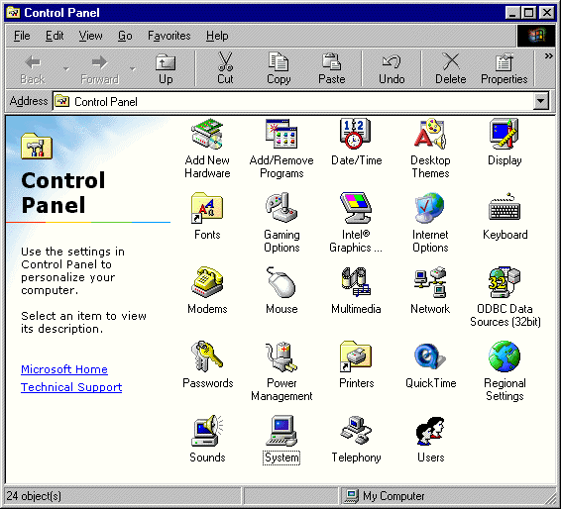
Alternate: Click My Computer 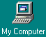then Control Panel 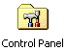then Network .

Either route will bring you to the same Network screen below.
Remove components from the bottom up.
First, highlight TCP/IP->Dial-up Adapter and click Remove.
Then highlight Dial-up Adapter and click Remove.
Then highlight Client for Microsoft Networks and click Remove. (Optional)
IMPORTANT: DO NOT CLICK OK IF you do not have your Win98 CD or .cab files.
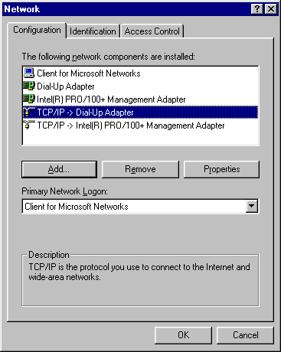
Note: Windows 95 and earlier version of Windows 98 added tons of extra, unnecessary adapters and protocols to the Network section of the Control Panel. These include:
Microsoft Family Logon
Client for Novell Networks
Dial-Up Adapter #2 for VPN Support
TCP/IP -> Dial-Up Adapter #2
IPX/SPX Compatible Protocol
NetBEUI
AOL Adapter
TCP/IP -> AOL Adapter
Simply click on the undesired entry, then click the Remove button. Don't worry about Ethernet cards, etc. TCP/IP bound to a network adapter card (e.g. TCP/IP -> Intel Pro/100+ Adapter in picture above) is totally irrelevant to your modem connection to the internet.
After removing TCP and Dial-Up Adapter and any others, click OK.
!! ONLY Click OK IF you have your Windows CD or .cab files !!

If using .cab files, the following error will pop up after clicking OK. It's looking for your CD-ROM, which you aren't using. Just click OK to continue.
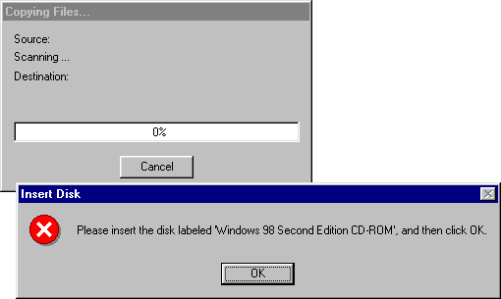

The following screen is asking where your .cab files are stored. In the "Copy files from" box, type the path to the folder where the .cab files are stored. This is the path you found by going to Start->Find as described above in the section on finding .cab files.
Note: Many computers have these stored in "C:\Windows\Options\Cabs".
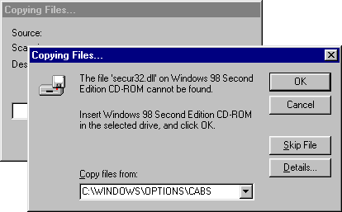

From our example, the .cab files were in C:\WIN98. The example below shows this typed in.
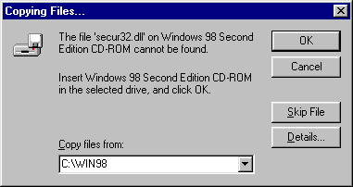
Click OK. You will see files being copied, after which you will be asked to restart.

Click No when asked to restart your computer. We still need to uninstall DUN before rebooting.
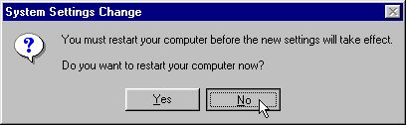

Uninstall Dial-Up Networking:
Open the Control Panel by going to Start->Setting->Control Panel.
Double click Add/Remove pictured at the top of the Control Panel below.
Alternate: Click My Computer -> Control Panel -> Add/Remove .

Either route will bring you to the same Add/Remove Programs Properties screen.
Click the Windows Setup tab to see the screen below.
Highlight Communications, then click the Details button.
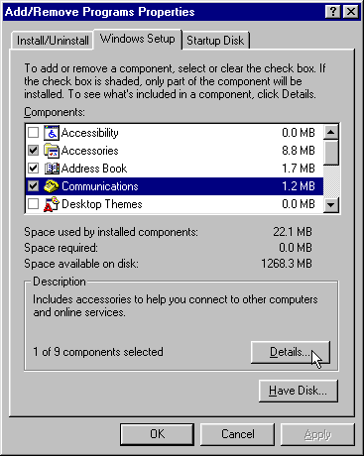

The Communications screen will appear, as shown below.
Remove the check-mark in front of Dial-Up Networking and click OK and then OK again.
!! ONLY Click OK IF you have your Windows CD or .cab files !!
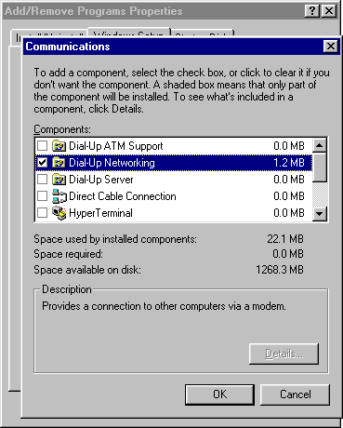

If using .cab files, the following error may pop up after clicking OK. It's looking for your CD-ROM, which you aren't using. Just click OK to continue.

The following screen is asking where your .cab files are stored. In the "Copy files from" box, type the path to the folder where the .cab files are stored. This is the path you found by going to Start->Find as described above in the section on finding .cab files.
Note: Many computers have these stored in "C:\Windows\Options\Cabs".
Click OK. You will see files being copied, after which you will be asked to restart.

Click Yes to restart your computer.
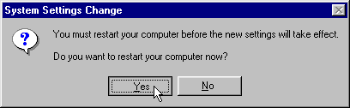

Reinstall:
Easy Route: Reinstall All 3 at Once with the inetwiz:
After removing the networking components and rebooting, the easiest way to reinstall fresh copies of DUN, TCP, and Dial-up Adapter is to run the Internet Connection Wizard (inetwiz). This has the added benefit of also creating a brand new DUN connection as well.
Below is a brief explanation of the install using the inetwiz. Click here for a full walk-through.
If you're familiar with the inetwiz, you'll see two new screens that may appear at first to be errors.
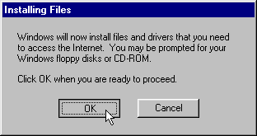
Click OK. You will see files being copied.
After the files are copied, continue through the rest of the inetwiz. Click here for a full walk-through.
After completing the inetwiz, you will see what appears to be an error. Don't worry; this is not really an error. Since you haven't restarted the computer since installing DUN, the inetwiz doesn't recognize the connection it just created.
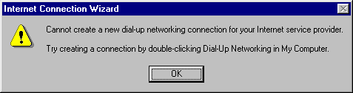
Simply click OK and restart your computer.
You will have fresh copies of DUN, TCP, and the Dial-up Adapter, as well as a brand new DUN connection.
Click here for a full walk-through of this process including complete inetwiz screen shots.

Longer Route: Reinstall DUN separately:
If you do not want to use the inetwiz to reinstall everything, you can install them separately. This will take a little longer.
To reinstall DUN, follow the same process as outlined above for uninstalling DUN. This time, though, instead of removing the check-mark, you'll be adding a check-mark in front of Dial-Up Networking.
Click here to jump up the page to the instructions on DUN.

Longer Route: Reinstall Network Components Separately:
If you do not want to use the inetwiz to reinstall everything, you can install them separately. This will take a little longer.
To reinstall TCP, the Dial-Up Adapter, or the Client for Microsoft Networks, click the "add" button. You will choose "Adapter" to install the dial-up adapter, or "Protocol" to install TCP/IP, or "Client" to install Client For Microsoft Networks. You will then get a prompt with two boxes. Scroll down the box on the left to highlight "Microsoft" then double-click the appropriate component in the right box. Full screen shots for installing any of these 3 are shown on a special page.

Rebuilding winsock.dll and wsock32.dll
You either have VERY erratic connections or you can't surf or e-mail at all. You've reinstalled DUN, TCP/IP and the dial-up adapter but you still can't do anything more than connect. What do you do? Try reinstalling Winsock.
Wsock32.dll and winsock.dll are both winsock. The older winsock.dll is a 16-bit app that was used in Win 3.X and Win95a. Microsoft came out with OSR2 Win95b versions that replaced winsock.dll with wsock32.dll which is a 32-bit version of winsock. The vast majority of people use the newer wsock32.dll because the original version doesn't work very well. All Win98 boxes use the newer wsock32.dll.
Choose the version of operating system that needs a winsock reinstallation:
winsock.dll (Win95a)
wsock32.dll (Win95b a/k/a OSR2)
wsock32.dll (Win98) (system file checker route)
After doing this, you will have refreshed ALL of the networking components on your computer. If you are still experiencing problems, the last thing to try would be to upgrade your modem driver or to reinstall the modem completely. Click here to go to the next page with help with modem issues.

